Tate Seifert

Channel Post Link to site Image URL Image
Facebook | New year, new ______ gala coming Nov. 11 of this year! Join us for food, drinks and an extravagant night at the ___________. All proceeds go toward educational funding for schools, and low income families to get community memberships. Get your tickets today! | https://www.perotmuseum.org/tickets/ | https://bit.ly/3KfltCp | 
Facebook | Ever wondered what stories a National Geographic Explorer has to share? We love the inspirational and thought provoking stories it shares, which is why we host our National Geographic Live speaker events! Hosted by Charles Schwab, this three part event offers a variety of awe inspiring tales from the adventurous staff of National Geographic. Check out our events page for more information. | https://bit.ly/3G41tjA | https://pixabay.com/photos/event-venue-auditorium-meeting-1597531/ | 
Facebook | Children are our future. Here at the _____, we strive to offer the best learning experiences and inspiration to all our young learners. This is why our _________ program is very important to us. Give your child the best hands-on experience with Science and discovery this summer. Register your little Einstein now! | https://www.perotmuseum.org/events/children-and-families/discovery-camps/summer-registration/ | https://pixabay.com/photos/teaching-child-world-geography-928637/ | 
Facebook | Ever wish the _______ could come to you? We do too, which is why we offer our ____ truck service for underfunded schools and communities. This program offers hands-on learning in science, technology, engineering, arts and math (STEAM). To learn more about the program and how to get a ____ truck to your school, community center, or non-profit organization, learn more today. | https://www.perotmuseum.org/events/children-and-families/tech-truck/ | https://pixabay.com/photos/schoolbus-happy-smile-boy-7371654/ | 
Facebook | We have our events down to a science here at ______. Host your next corporate event among our unforgettable exhibits and halls for groups from 25 all the way to 1,500! Guests are welcome to explore all 5 floors of the museum, with a variety of floor plans to choose from. Submit a request today! | https://www.perotmuseum.org/events/host-an-event/#_corporateprivateevents | https://pixabay.com/photos/affair-anniversary-attractive-1238434/ | 
Twitter | Our #volunteers are the heart of ______ and all of its operations. We offer opportunities to anyone 14 and up. Sign up to our team today! | https://bit.ly/3nAi9sU | https://pixabay.com/photos/lesson-back-to-school-education-1014915/ | 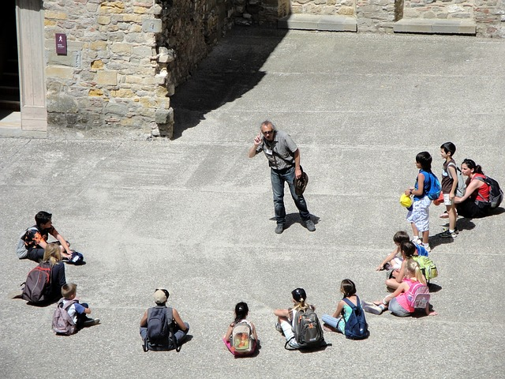  170 characters
Twitter | #Education is always changing. Besides our physical exhibits and displays, we now offer many online resources for all ages. What are some of your favorite online programs? | https://bit.ly/3TWlAG5 | https://pixabay.com/photos/homeschooling-school-technology-5121262/ |   194 characters
Twitter | What’s better than award winning museum exhibits? Award winning museum exhibits with our favorite #brews just for the adults! ______ is back this summer with an open museum, drinks and food. Get tickets now! | https://bit.ly/40tyG05 | https://pixabay.com/photos/beer-draft-glass-lager-brown-glass-2689537/ |   238 characters
Twitter | Ever considered being a member of ______? Members receive a variety of perks from free general admission, half off museum parking, shopping and dining discounts and much more. Sign up today! | https://bit.ly/3G2gkv9 | https://pixabay.com/photos/visitors-exhibition-see-museum-art-1649815/ |   222 characters
Twitter | #Community engagement is a huge part of our values. #Educating and encouraging all of our guests in and outside of the museum drives us. Learn more about our many programs here | https://bit.ly/3G1rm3A | https://pixabay.com/photos/team-group-people-motivation-386673/ |   198 characters
Instagram | Do you have your tickets, but have a few questions about what to expect? Take a look at our informative page covering just that!  The #museum strives to make the experience as seamless as possible. We put our cutting edge technology to good use through our use of digital tickets. This system allows our guests to scan in seamlessly at our front entrance. For anyone with questions on the location, we also have a map and options for directions.  See the link in our bio for more information.  #museum #green #dallas #science #tickets | https://www.perotmuseum.org/visit/know-before-you-go/ | https://pixabay.com/photos/ticket-number-win-play-luck-1539705/ | 
Instagram | All of our Pixar fans are in for a treat with our new ________ event! New displays demonstrating the magic of animation will be up throughout the day. Our life-size replicas of many characters are waiting to make the perfect selfie! Come pay Lightning and Sulley a visit!  Whether it’s “Monsters Inc,” or “Cars,” we have everyone's favorite characters waiting to teach our young guests how it all works! | https://www.perotmuseum.org/exhibits/the-science-behind-pixar/ | https://pixabay.com/photos/cars-lightning-mcqueen-pixar-disney-7101111/ | 
Instagram | Every day we get to welcome bright young minds into our museum. We take great pride in our many exhibits and displays that get these kids excited to learn.  Our permanent exhibits feature a variety of fossils, which a lot of were uncovered right here in Texas! Dinosaurs and many other creatures walked this ground long before we did.  We welcome guests young and old to come explore our five floors packed with a learning experience around every corner. The world of science is a perfect place to visit for the whole family. Check our link in the bio to get tickets today!  #museum #science #learning #familyfun #education | Link to main site in bio | https://pixabay.com/photos/child-kid-play-study-color-learn-865116/ | 
Instagram | Field trips to the museum can change the course of a young mind's educational future. We believe that the ability to pay shouldn’t be a barrier between students and learning. Schools that apply for our program receive a discounted price per student, as well as further aid if needed.  Here at ______, we believe everyone deserves an opportunity to learn. Our financial aid and community outreach programs make sure no child is left behind. For more information, check the link in our bio.  #communityoutreach #financialaid #schools #nonprofit #learning | https://www.perotmuseum.org/support/financial-aid-and-community-partners/ | https://pixabay.com/photos/kids-girl-pencil-drawing-notebook-1093758/ | 
Instagram | Our employees and volunteers make what we do possible. Recognizing our many scientists in the field finding fossils or our museum staff keeping our computers and events running is a pillar for us. We appreciate and recognize everything they do.  We’re always in need of more volunteers and team members. ______ offers a variety of positions for both volunteers and employees.  Our team is the heart of our operation. We offer many perks and opportunities to every member of our staff. Our careers page is linked in our bio if anyone wants to join our team!  #careers #employeeappreciation #teamwork #museum #science
Share | Texas is our home, and like our halls, we like to keep trash out. Trash Free Texas is an organization looking to do just that. It’s website offers updates and volunteer opportunities for everyone looking to make a difference in our miraculous state. | https://www.trashfreetexas.org/?gclid=Cj0KCQjww4-hBhCtARIsAC9gR3bpTfdELRHU2W2rzbj6nlyhpHILH8BYcrZD0FJ_GGnpNeNWO0hE6WAaAsDpEALw_wcB
Share | Teaching our young minds science and math is vital. Start Early has many resources to begin your little one's journey to education in STEM. Learn more today. | https://bit.ly/3JWwQOr
Share | Studies show that 90 percent of the human brain develops within the first five years. Early education is vital for all young minds and utilizing all the tools we have available to us is easier than ever. Check out what ChildCareGroup has to say about this amazing topic. | https://bit.ly/3JUXLtJ
Share | Anthropology is a very fulfilling career. Our friends over at UTA offer some insight into their program for students. Check out their website for more information. | https://www.uta.edu/news/news-releases/2022/06/13/field-school-lemke22
Share | What’s the best way to ensure your kids are living a healthy lifestyle? By getting them outside! Camp Fire has more information on why time in nature is vital for developing minds. | https://campfire.org/blog/article/big-benefits-nature/

